Nanocomposites and nanomaterials

Electrospinning of nonwoven materials based on biocompatible polymers
І.V. Ohrimenko, O.V. Ishchenko, V.P. Plavan, M.K. Koliada, I.O. Liashok
Chemical Technology and Resource Saving Department, Kyiv National University of Technologies and Design, Nemyrovycha-Danchenka Street, 2 Kyiv 01011, Ukraine. E-mail: e.ishchenko5@gmail.com
Nanofibrous nonwoven materials successfully obtained by the method of electrospinning. First, this is due to the possibility of sourcing nano- and microstructures from several biodegradable, biocompatible and bioinert polymers. In addition, this technology allows adding various active pharmaceutical ingredients, even at the stage of development of the formulation solution [1].
Presenter study aimed creating nonwoven nanofibrous materials with antiseptic properties based on PVA, PVAс with the addition of gelatin and chlorhexidine.
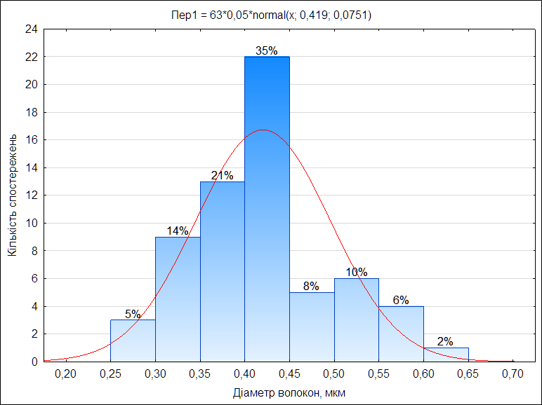
The parameters of obtaining fibers by the electrospinning method were determined by the optimal voltage of 30 kV and the distance between the electrodes – 14 cm, using a capillary with a diameter of 1.1 mm.
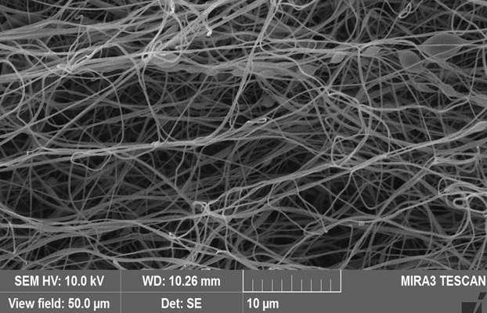
Fig. 1 – Photomicrograph and histogram of fiber diameter distribution based on the composition of PVA/Gelatin (8:2 ratios)
The obtained nonwoven materials from PVA/Gelatin and PVAс/Gelatin compositions have a fiber diameter in the range of 0.10-0.65 microns (Fig.1). Materials based on PVA/Gelatin have most fibers with a diameter of 0.12-0.32 μm, and in materials based on PVA only 19% of such fibers.
Thus, the addition of gelatin makes it possible to obtain fibers with a uniform diameter distribution. The use of gelatin allows to expand the scope of applications of the obtained nonwoven polymer materials due to the reactive groups of collagen and the possibility of their combination with other active pharmaceutical ingredients.

1. Koliada M., Ishchenko O., Plavan V., Bessarabov V. Characterisation of electrospun fibers made of PVA or PVAc and collagen derivative / // Vlakna a textile. – 2018. –25 (2). – P. 48–52.

