A DEFECT CONTAINING FEEDBACK PHOTONIC STRUCTURE FOR THz AND INFRARED BEAMS COLLIMATION
Glushko, E. Ya.

Semiconductor Photonic Structures Lab., Institute of Semiconductor Physics of NAS of Ukraine Nauki Prsp., 45, Kyiv -03028, scientist.com_eugene.glushko@mail.com

Developing the idea to use the extraordinary narrow resonance peaks of transmission on the background of perfect reflection arising in a planar photonic resonator containing a unitary defect in the middle of the structure [1], we propose here a modified tool which can redirect the -φ_{r} J_{r}/2 beam (Fig. 1) back into the resonator’s electromagnetic field reservoir due to a feedback construction. This enables to obtain a collimated unitary outgoing +φ_{r} beam of full intensity J_{r} instead J_{r}/2 otherwise. The properties of standing modes inside the polyethylene (polypropylene)/silicon plane resonators in the total intrinsic reflection region and unusual manifestations of THz transmission spectra in centimeter and millimeter wavelength range were studied in [2]. It was shown that the angle and frequency half-widths of the resonance peak can be less than 10⁻⁹ of the magnitude of angle and frequency in dependence on the number of periods. This allows one to form collimated beams with the divergence measured in a fraction of a microdegree. It is shown that a plane resonator containing a central defect transforms the frequency divided peaks into the outgoing-transmitted beams of various directions like a prism transforms light. In the talk, the way for precision measurements of angle and frequency distribution of THz radiation is discussed.
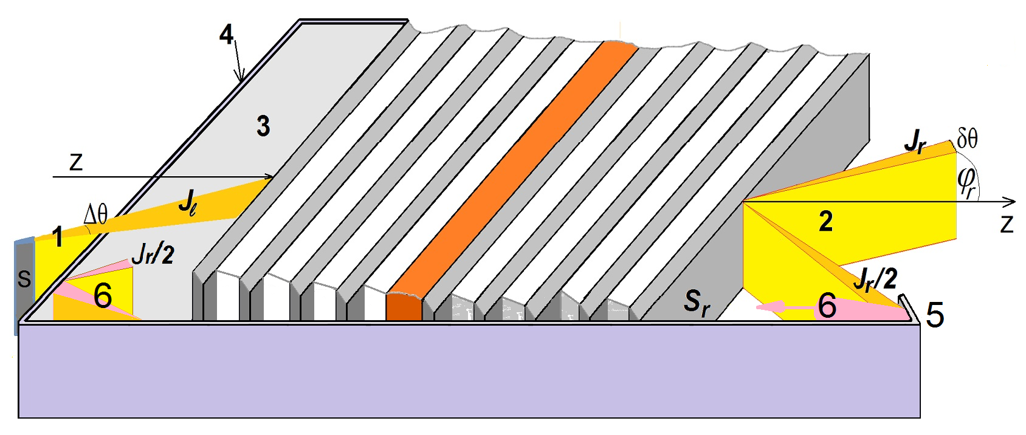
Fig. 1. A planar central defect containing photonic crystal resonator with feedback reflector. 1, monochromatic diverged incident beam J_{l}; 2, collimated outgoing beams J_{r}, 3, electromagnetic field reservoir; 4, mirror walls of the reservoir, 5, feedback reflector, 6, reflected -φ_{r} J_{r}/2 outgoing beam; φ_{r}, output angle; Δθ and δθ are the input and output divergence of beam, correspondingly.
The idea of collimating device is presented in Fig. 1. A monochromatic diverged incident beam J_{l} passes from the source S into the resonator through an electromagnetic field reservoir (EFR). The latter allows one in a lossless process to concentrate inside the radiation of different directions with the angular white noise distribution.
For the THz frequency range, we consider a polypropylene-silicon (Si/PP)_{n}/D/ (Si/PP)_{n}/Si defect containing photonic structure for various number of periods n. As a defect, the Si-layer was taken. To obtain collimation, the source frequency should be matched with the calculated resonant curve of transmission which occupies interval (0.59076, 0.69275) THz at chosen geometrical sizes of resonator Si - 40 µm, PP - 70 µm, D - 40 µm, n=5. In the vicinity of 0.6 THz for the adopted parameters: I_{l} =0.1 W/cm², source section 12.5 cm², output section 12.5 cm², EMW reservoir volume 1257cm³ time of energy accumulation equals approximately 3.78 ms. The ratio of energy loss on the reservoir walls and the reverse flow through the source section was taken as 28%. As a result, the considered system issues a strongly collimated beam with angular HWHM δθ close to 0.123 μDeg and output intensity J_{r} =0.07142 W/cm².
To operate inside the IR range we have chosen for consideration an optically enough contrast 10-period layered structure consisting of alternating 0.6 µm silicon films divided by 1.2 µm SiO₂ layers with a defect Si layer in the middle of structure and ending additional layer of Si. On the upper panel of Fig. 2, shown is spectrum of standing modes calculated inside the TIR angular region (shown is interval (17° – 23°). The considered interval of energies (0, 1.0) eV involves five bands divided by four gaps containing local (surface and defect) states. The first gap occupies interval (0.148, 0.238) eV and contains a defect and twin in vicinity of TIR angle 17°. Beginning with 18.2° incident angle of waves inside the Si layers, that quasi-degenerated surface state transforms into two detached band modes. We discuss perspective use of standing TIR modes in photonics applications.
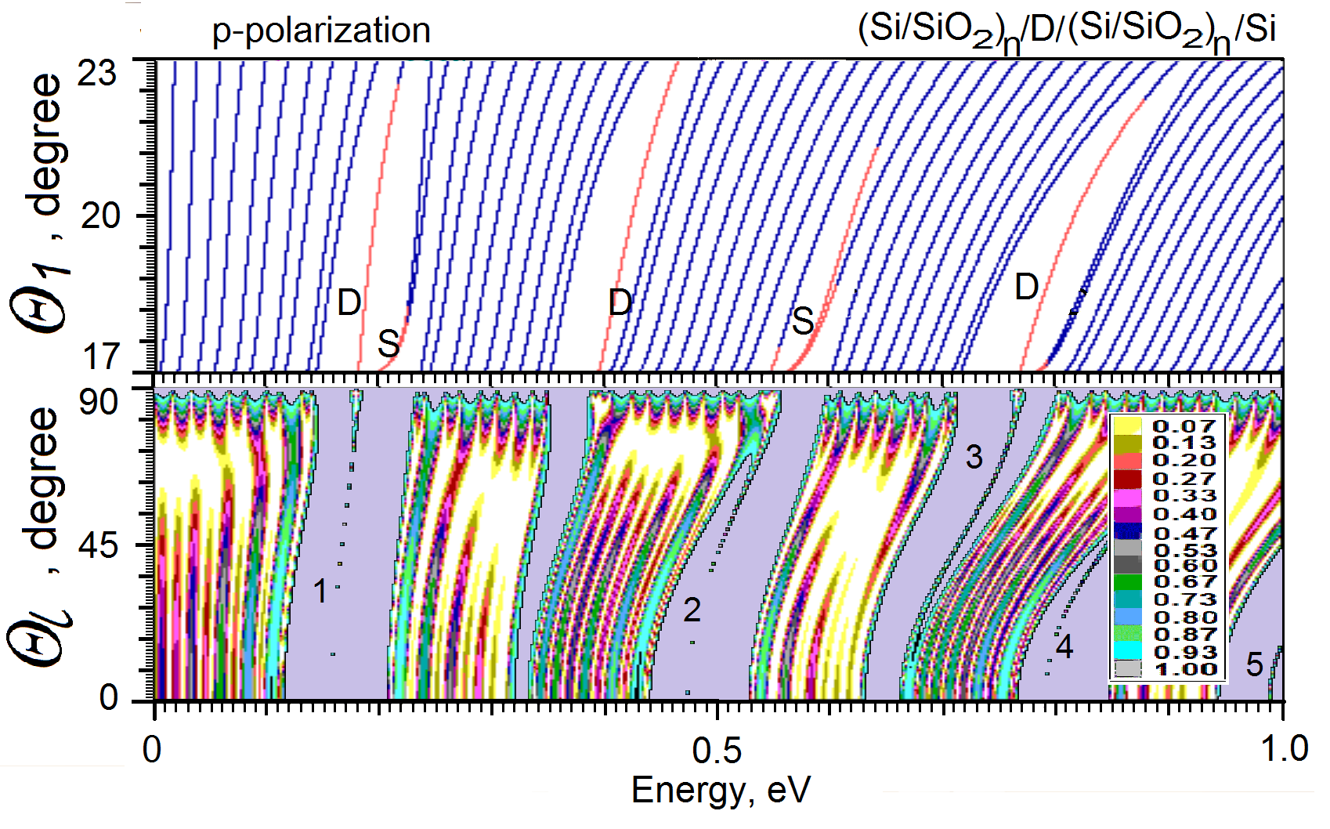
Fig. 2. Spectrum and reflection diagram of a defect containing photonic crystal resonator (Si/SiO₂)_{n}/D/(Si/ SiO₂)_{n}/Si, n=5. Upper panel: D, defect modes; S, surface local modes. Lower panel: Color diagram of reflection in the external geometry of incidence. Six windows of perfect reflection. 1-5, local (defect) resonances of perfect transmission. Inset: color scale of reflection.
On the lower panel of Fig. 2, the calculated color map of reflection is shown. Six windows of transmission divided by zones of perfect reflection correspond to bands and gaps of spectrum of the structure presented in the upper panel for the TIR angular region. The physical nature, properties and behaviour of local resonances 1 – 5 were analysed in [1, 2].
The proposed scheme of feedback redirection of electromagnetic energy allows one to avoid the doubled outgoing beam and to rise power of the beam outgoing in the needed direction. In this talk, we also discuss a new spectroscopy technique based on the existing sharp transmission resonances using the conception of accumulating reservoir of electromagnetic field. One more subject of discussion is an opportunity to form long and stable channels of communication and energy transportation in the infrared and THz frequency ranges.
References
- E.Ya. Glushko. “Collimation Effect on THz Transmission Resonances in Metalized and Defected Photonic Structures” in Research Trends and Challenges in Physical Science, edited by Prof. Shi-Hai Dong, vol. 1, Chapter 7, 83-89. B P International UK (2021).
- E.Ya. Glushko "Local resonance based precision collimation of THz radiation in a defect containing 1D photonic resonator: spectroscopy and metrology" Eur. Phys. J. D (2022) 76:130

